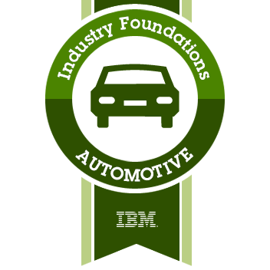

This badge was issued to [Mehmet Cambaz](https://www.youracclaim.com/users/mehmet-cambaz) on 22 January 2020

<https://www.youracclaim.com/badges/1c90cc42-2507-4da6-abc7-7cf0c5ac1a5f>